Gay Games VI Wrestling Post Event Report

Authors: Peter Verey And Kurt Brinschwitz, Wrestling Sports Working Group

Gene Dermody, Federation of Gay Games Wrestling Co-Ordinator

Date: November 19, 2002

Contents

Gay Games VI Wrestling Post Event Report 1
1. Overview 2
2. Competition Committee Structure 4
3. Officiating 5
4. Competition Format 6
5. Scheduling of events 8
6. Athlete Participation/absenteeism 9
7. Venue 10
8. Support Services 11
9. Ticketed events 13
10. Sponsorship and Income potential for your sport 14
11. Appendix (1) GG VI Wrestling Program 15
12. Appendix (2) Wrestling Novice Workshop held Sunday 3 November 02 17
13. Appendix (3) Competition Format and Rules 18
14. Appendix (4) GGVI Staff List 19
15. Appendix (5) Frequently Asked Questions posted on website 23
16. Appendix (6) Wrestling Athletes’ Guide 27
17. Appendix (7) Wrestler Bio Sheet 38
18. Appendix (8) Wrestler Weigh In Sheet 39

Overview

The wrestling event was held over two days at the Anne Clark Netball Centre, in Lidcombe, NSW. A summary of participant numbers follow. For a detailed breakdown of participant numbers, refer to Part 6 of this report – Athlete Participation/Absenteeism.

1.1 Registered Participant Numbers
As of the morning of Sunday November 3rd, the Wrestling event had a total of 125 registered participants, with 101 participants registered for the competition and 24 registered for the Novice Workshops.

The breakdown of registered participants was as follows:
Males: 121 Females: 4

Novice Category 24 registrants
Open, Male 29 registrants
Open, Female 4 registrant
Masters, Male 68 registrants
Masters, Female 0 registrants

1.2 Actual Participants in Novice Workshops

We note that more than 24 people participated in the novice workshop day – that is, several of the more advanced wrestlers, who were competing in the masters or open events, participated and helped coach the more inexperienced wrestlers. This was encouraged, as part of the aim of the Sunday was to give athletes a chance to “break the ice”.

1.3 Actual Number of Competitors

Actual numbers of competitors were obtained from the competition tables for each weight and age category prepared by the Pairers after weigh-in.

According to these tables there were 82 athletes that weighed in and competed. The breakdown follows:

- Women – 4 competitors
- Open Mens – 35 competitors
- Masters Mens – 43 competitors

There were 19 athletes who registered but did not weigh in. For a detailed breakdown of participant numbers, refer to Part 6 of this report – Athlete Participation/Absenteeism.

It is noted that there were two athletes (one male and one female) who could not, or did not, attend the Medical and Weigh-in and wanted to know if they could still compete. They were advised that they could not enter the competition. The rules were very clear. All athletes must attend the Medical and Weigh-in in order to be eligible to compete. These athletes were also advised that, if they wished, they could arrange a “special bout” with another wrestler of similar age and weight. Neither wrestler took this option.

Copies of the completed competition tables for all weights and ages have been circulated in electronic format to Gene Dermody and Rick Van Tassell. These tables show actual number of competitors for each weight and age category.

1.4 Countries & Cities Represented
The following Nations (and athlete numbers) had registered for wrestling at Sydney 2002 Gay Games VI:
Arab Emirates | 1
Australia | 18
Belgium | 5
Canada | 9
Germany | 10
France | 2
Hong Kong | 1
Ireland | 1
Netherlands | 1
New Zealand | 1
United Kingdom | 2
United States | 74
TOTAL | 125

Athletes originate from the following cities:
Abu Dhabi, Amsterdam, Antwerp, Arlington, Austin, Ballinasloe, Bay Shore, Berlin, Brisbane, Brooklyn, Chicago, Christchurch, Clarks Summit, Colorado Springs, Concord, Denver, Edinburgh, Fort Lauderdale, Frankfurt, Harrisburg, Heilbronn, Honolulu, Jackson Heights, Kapa'a, Koenigheim, Lake View Terrace, Linden, Long Beach, Los Angeles, Melbourne, Milton, Montreal, New York, North Point, Paris, Philadelphia, Portland, Pulle, Reading, Rieschweiler, Rolleston, San Diego, San Francisco, Santa Rosa, Seattle, Smyrna, St. Petersburg, Stuttgart, Sydney, Tampa, Tucson, Vallejo, Vancouver, Verdun, West End, Wilrijk, Winnetka and Würzburg

1.5 Programme and Appendices
- Refer to Appendix 1 for the wrestling program for the two days.
- Refer to Appendix 2 for the novice day programme.
- Refer to Appendix 3 for the competition format and rules used.
- Refer to Appendix 4 for a list of the staff (volunteers) used. In all about 40 people contributed to the running of the event; this includes officials, pairers, marshalls, ticket collectors, medical and setup/takedown staff.
- Refer to Appendix 5 for the list of FAQs that was posted on the gay games website. This includes justifications for the changes to FILA rules (as shown in appendix 3).
- Refer to Appendix 6 for the Athlete's Guide that was provided to athletes for information about the event.
- Refer to Appendix 7 for the wrestler bio-sheet used to provide information for the announcer and medal presentation ceremony.
- Refer to Appendix 8 for the wrestler weigh-in, medical and accreditation sheets used.

Note that for privacy reasons, all volunteer surnames and contact details are omitted.

Competition Committee Structure

Under the Agreement between Sydney 2002 Gay Games Limited (“Sydney 2002”) and New South Wales Wrestling Association Incorporated (“NSWWA”), Sydney 2002 paid NSWWA $5,000 for all the sports equipment and officials required to run the competition. NSWWA ran the competition on the day of the event.

We would strongly recommend replicating this formula for the next Games. It had the effect of bringing the Association into the event. It also assisted in bridging the gap allowing our club members to actively train in other Sydney clubs and compete at NSWWA run tournaments.

A copy of the final staffing positions filled is attached as a separate attachment to this report. Please see Appendix 4 for details.

The golden rule in sourcing volunteers was to source as many as possible from our sport. They understood the sport and we knew that they were more likely to show on the day. We strongly recommend that this formula be repeated where possible. All volunteers showed for the event. Most had some knowledge of the sport. Sourcing of volunteers was as follows:

- All officials including the two competition managers, referees, pairers, timers and scorers were sourced through NSWWA.
- The Athlete FOP Coordinator was sourced through our sport. He did the same role at the Sydney 2000 Olympics.
- The Announcer was a non-sport person who announced for Wrestling at the Sydney 2000 Olympics.
- The equipment set up and take down people were all current members of our own club, Harbour City Wrestling.
- The Athlete Marshals, Weigh-in recorders and blood people were all sourced through Harbour City Wrestling.– either past wrestlers who no longer participated actively or friends of our current wrestlers.
- The only positions which the Games organising committee sourced for us were the spectator coordinator, spectator marshals and ticket rip people and medical support staff.

Note:
As Wrestling occurred on a Sunday and Monday, some volunteers could only assist on the Sunday and not the Monday (being a work day). This meant that for some positions such as Marshals, we had two sets of volunteers.

Officiating

For further details, refer to section two above. Sydney 2002 paid NSWWA $5,000 for all the sports equipment and officials required to run the competition. All technical officials were volunteers. See the attached staffing position list in Appendix 4.

There ended up being five (5) referees (including one of the competition managers). As there were two competition mats, it had been agreed prior to the competition that there would be no mat chairman or judge. Instead, there was one referee on the mat and a scorer. At the end of each bout, the winner was asked to sign his/her bout sheet as a double check. This seemed to work quite well. It allowed the alternate referee to rest in between matches. We recommend this format for future competitions.

We were interested to learn that after the competition, the Head Referee in FILA (the Wrestling IF), Rick Tucci, asked the American referee for his feedback on the competition. This highlights that FILA is clearly interested in knowing how the event is being run.

Competition Format

The wrestling event was a two-day program including two novice training workshops, as already described in the overview.

The competition itself consisted of four separate divisions, separated by age and gender. Open (less than 35 years old) and Masters (35 years and over) for both Men and Women. In accordance with the competition rules, there were also special bouts arranged with the agreement of the athletes and the head referee.

There were specific rules for this competition, which modified the FILA rules in certain aspects. Refer to Appendix 3 for further details of the rules.

Observations

- In practice, one of the most important measures which secured the success of this event were the athlete briefings which were held during the first day of the event, prior to the weigh in. There were three athlete briefings, the first two being to explain the scale calibrations between the check scales and the weigh-in scales and the third being a general briefing explaining the rules of the competition, happening immediately prior to the weigh-in.

- The athlete briefings were crucial as it became apparent that some wrestlers did not understand the pairing rules for the competition or the rationale for using these rules. The final briefing also included a talk by one of our Competition Managers on a code of conduct for athletes and coaches. This included requirements for the shoes to be taped, the requirement to be carrying a handkerchief, shaking of hands before and after matches and abiding by the referees decisions. Together, this ensured that all athletes, coaches, pairers and organisers were on the one page prior to the start of the competition.

- In addition, prior to the start of the competition, the Head Referee demonstrated on one of the competition mats how points would be scored for certain moves during the competition. This further enhanced the level of shared understanding between athletes, coaches and referees.

- As a result, there was a good sense of camaraderie during the competition and athletes and coaches were well behaved. Whilst some decisions of the referees were questioned by the athletes, the decisions of the referees were accepted and there were no formal protests by athletes or coaches.

- The Novice Workshops were also crucial to the success of the competition. These Workshops helped “defuse” much of the tension and competitiveness of the event. This is particularly important as the participants in the event come from a wide range of capabilities, from absolute novices to seasoned athletes. By using the novice day to help get athletes to know each other and break the ice, a friendlier, less competitive atmosphere was maintained. The local gay wrestling club, Harbour City Wrestling, invited athletes who had arrived earlier in the week to participate in club training prior to event, further aiding the process of wrestlers getting to know each other.

- The rules of the competition (posted on the website) allowed competing athletes in the Masters category to elect to compete in the Open division if they so chose. Those athletes in the Open could not compete in the Masters. The reason for this rule was to minimise risk of injury. This rule lead to about 19 athletes changing their registration to the less-well attended Open division, ostensibly to improve their chances of winning a medal. As it turned out, these “Masters” wrestlers were often fitter and more experienced than their Open division competitors, and hence usually dominated. While this situation was allowed under the rules, some discussion took place after the competition as to whether it would be more ethical in future not to allow this. This issue is currently being discussed by members of Wrestlers Without Borders.

- Scheduling the weigh-in for the day before the competition is standard practice in international tournaments and was accepted by athletes and organisers. For the athletes, it allowed those who had cut weight to carbo load prior to the competition. For the organisers, it allowed the pairers to pair the competition in advance, allowing the competition to start promptly the following day.

Scheduling of events

We believe it was good planning that Wrestling was held on the first couple of days of the competition. This ensured that athletes did not have to maintain or cut their weight over the entire week of the event.

We also believe it was good planning that Wrestling was a two day event. We do not believe it would be a good idea to extend this to three days, as it would stretch the resources and goodwill of the volunteers.

In terms of what happened in these two days, we believe the activities were well scheduled. The 2 x 2 hour novice workshops worked well. There had been some talk earlier about including a demonstration of other wrestling styles in the one-hour time slot between both workshops. As it turned out, we included Final Entries in this timeslot, which allowed athletes to change their weight or age division. This was a more appropriate use of resources and allowed the weigh-in to proceed smoothly.

Several volunteers also attended a test event, which was run three weeks before GGVI wrestling event. This was the National Schoolage Tournament, run by NSWWA. This provided valuable insights into the running of a tournament of approximately the same size. It is recommended that organizers for subsequent Gay Games incorporate something similar if volunteers are unfamiliar with the running of such tournaments.

Additionally, another important factor that contributed to the success of this event most of the volunteers had attended the Wrestling Staff training session prior to the event (approximately 30 out of the 40 or so volunteers attended). This was held the Sunday prior to the Games over a two hour period. This was aimed primarily at volunteers who had no background in Wrestling. It included a general overview of the sport, a venue tour, a run through of the schedules for the two days, question and answer sessions regarding individual roles and responsibilities and the opportunity to meet with other personnel who had experience in organizing and running wrestling tournaments. We strongly recommend that similar, wrestling specific training be given to non-sports volunteers for future Gay Games, ideally the weekend before the commencement of the Gay Games, so that the information remains “fresh” with attendees.

Athlete Participation/absenteeism

A. Summary

As of the morning of Sunday November 3rd, the Wrestling event had a total of 125 registered participants, with 101 participants registered for the competition and 24 registered for the Novice Workshops. There were 82 athletes that weighed in and competed. As the competition itself was only a one day event, there were no tapering issues as the week progressed.

A detailed breakdown on competitors is listed below. In summary, there were 19 athletes who registered for the competition and did not show.

The unexpectedly low turnout of women in the event is partly explained by low number of women participating in the sport locally. Although the organisers made every effort to encourage greater female participation, low turnouts resulted. As a consequence, only two of the four competing women were in the same weight and age division. Consequently, there were some exhibition matches arranged (in adherence with the strict safety and risk minimisation policies in place). Hopefully future Gay Games will be able to entice greater numbers of females to both compete and participate in the novice workshop.

Athlete participation and enthusiasm was very good, with a generally friendly air. Many athletes congratulated the organizers on the generally smooth running of the event, as well as praising the volunteers (especially the marshals and medical support staff).

In addition, a substantial number of athletes (more than half) showed up to non-official events such as training with the local wrestling club on Wednesdays and Fridays both before and after the conclusion of the wrestling event.

One recommendation for change to minimise tapering athlete participation in future would be to have the participation medals collected at the competition venue after competition has finished.

From the Games perspective, the authors believe that too many resources were devoted to non-sport activities such as the 5 dance parties. The philosophy of Dr Tom Wardell was devoted to sport, not dance parties. Certainly looking at the Olympics as another model, the Olympic movement has an opening and closing ceremony, it does not have 5 dance parties interspersed through the competition. If organisers are to get serious about athlete absenteeism, the Federation and the Organising Committees should refocus on the aims of the Games.

Part B. Detailed Breakdown of Athlete Numbers

The following statistics were derived by comparing the final database list of registrants (dated October 14th, after registration had been officially closed) with the competition bout sheets used on Monday 4th November. The bout sheets had the names of every athlete that had weighed-in and actually competed.

We note that we did not record the names of athletes that participated in the novice event, so it is unclear the exact number of people who either
- Turned up for the Novice day and then did not show for the weigh-in (i.e. dropped out from competition), possibly for reasons of inexperience or injury;
- Did not turn up to the novice day (no-shows).

Consequently the statistics cannot be accurately derived for the novice turnout. This is treated below in more detail.

Registrant numbers (Expected Turnout of Athletes)

The following statistics refer to the numbers of athletes that were registered to compete, and represents the number and categorisation that was expected.

Prior to the competition, the expected breakdown of numbers of athletes was as shown in the second column of Table 1. 101 competitors in open and masters division were expected, and another 24 in novice, to make a total of 125 participants.

The Third column shows the actual number of participants; with the fourth column showing the difference between actual and expected. 82 athletes ended up competing. As mentioned, the Novice numbers are not recorded for actual as these were not recorded, so the cells have not been filled in.

The fourth column looks at the difference between actual and expected show outs. Negative numbers indicate a deficit of competitors (i.e. less showed up than expected) and a positive number indicates a surplus (i.e. more showed up than expected). The total difference was 19 competitors (discussed in more detail further on).

Category | Expected # of participants | Actual # of participants | Difference
Masters Men | 68 | 43 | -25
Masters Women | 1 | 0 | -1
Open Men | 29 | 35 | +6
Open Women | 3 | 4 | +1
TOTAL COMPETITORS | 101 | 82 | -19
Novice Men | 21 | N/A | N/A
Novice Women | 3 | N/A | N/A
TOTAL NOVICES | 24 | N/A | N/A
TOTAL | 125 | N/A | N/A
Table 1: Summary Statistics of Athlete Turnout

The breakdown by groups is shown in Figure 1 below. Note in the legend that NW = Novice Women’s, NM=Novice Means, OW = Open Women’s, OM = Open Means, MW = Masters Women’s, MM = Master Means.

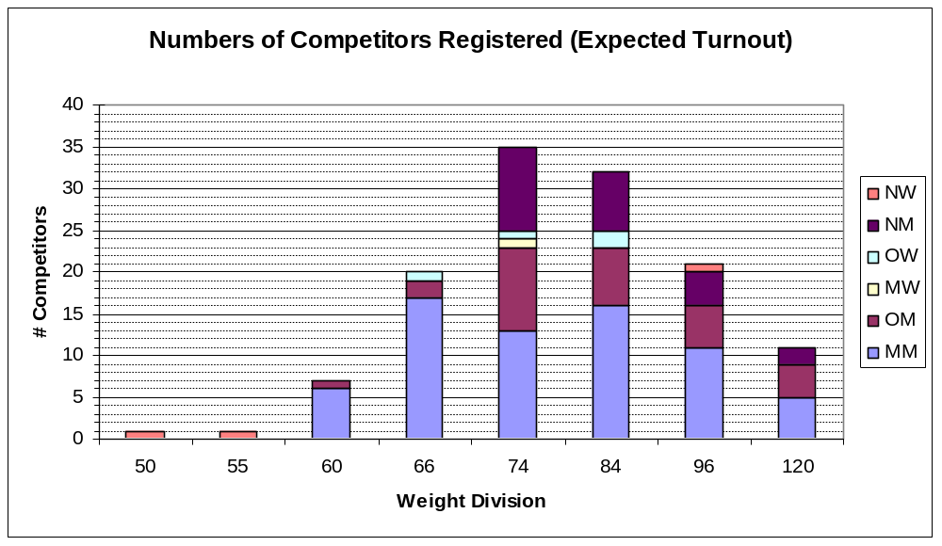
Figure 1: Expected Turnout of Wrestlers

Registrant numbers (Actual Turnout of Athletes)

The following data records the number of wrestlers that actually competed (total: 82). There is a difference of 19 wrestlers from what was expected, i.e. 19 more people had registered to compete in either the Masters or Open divisions than actually ended up weighing in and competing on the Monday. Refer to Figure 2 below to see the actual turnout numbers. Note that this graph does not include numbers in the Novice category, as this was not actively checked.

It is recommended that in future Gay games, the names of participants in the novice workshops are recorded, to aid in tracking non-shows.

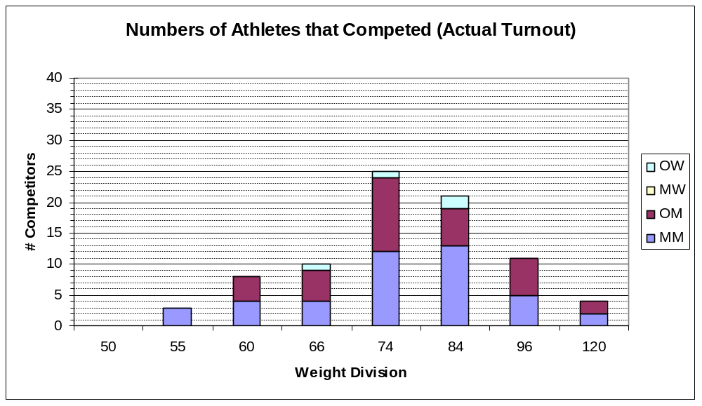
Figure 2: Actual Competitor Turnout

Difference between expected and actual turnouts

There are considerable differences apparent between the numbers of attendees expected and actual. Figure 3 below shows the differences across weight categories. A positive score indicates a surplus (i.e. more athletes actually competed than had been registered) and a negative score indicates a deficit (i.e. less wrestlers actually competed than expected). Summing across all categories, an overall deficit of 19 wrestlers is apparent (in agreement and subject to the comments above).

The changes shown occurred for two main reasons – category changes and non-competitors.
- Category changes indicate that a wrestler has changed either or both of weight class and division.
- Non-competitors indicate that a wrestler failed to wrestle in any of the divisions. They are investigated in greater detail below.

General Observations
- Masters Means under 66kg had the biggest shortfall (13 wrestlers). Some of these ended up competing in the Open Means 66kg (or 60kg) divisions. We note that 3 of the non-attendees were accounted for as no –shows (see below) so this is actually a shortfall of 10 wrestlers.
- The shortfall of one in Masters Women’s was taken up by that competitor wrestling in the Open Division, in the next weight category up. This was consequently classed as an exhibition bout.

Modifications due to Category Changes
39 category changes occurred – the breakdown as follows:
- 8 competitors changed from Masters to Open Category
- 1 competitor changed from Masters to Open Category (special bout category)
- 4 competitors, registered as Novice, ended up competing in the Open category
- 5 competitors, registered as Novice, ended up competing in the Masters category
- 21 competitors ended up competing in a different weight category than what they had registered in. Given the very hot nature of the day, and the strenuous training that many of the athletes were engaging in, this is understandable given the likely loss of weight through sweating.

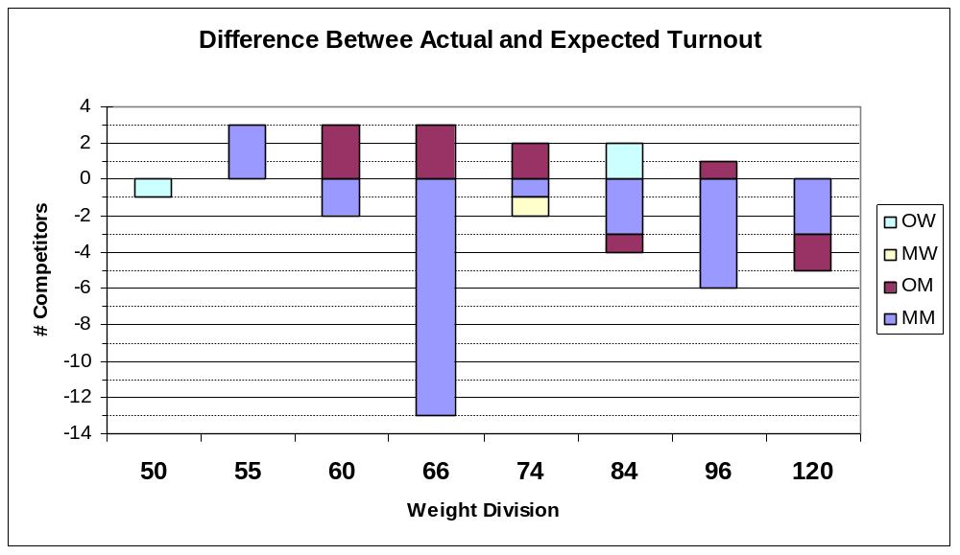
Figure 3: Differences between Actual and Expected Turnouts

Modifications due to Non-Competitors.
Comparing the database of expected registrants with the names of those athletes that competed, a total of 30 changes were noted. These 30 people had registered to compete in Masters or Open but did not. Analysis revealed the following:

- 2 athletes withdrew prior to competition and were replaced by other team mates
- 2 athletes withdrew prior to competition due to injury and were not replaced
- 3 last minute cancellations occurred (US wrestlers who could not make it out)
- 1 special bout (weighed more than 120kg and could not therefore compete under the guidelines of the tournament. The athlete did have a special bout though)
- 2 athletes participated in the novice day event but did not go on to compete
- 2 athletes withdrew as they were unable to attend the weigh in (one male athlete was attending another sport at the time and the other female athlete did not realise it was compulsory).
- 1 double registration (athlete competed but registration system had him listed twice under different surnames)
- 2 entrants listed as competing were actually coach/officials (registered to compete but had other duties) and so did not compete
- 15 no shows (registered to compete but did not show - may have been at the novice day event though)

As a consequence of the above, half of the changes or no shows were accounted for, with a total of 15 competitors unaccounted for. It is not known whether these athletes participated in the novice day or not and then did not weigh in, or did not show at all.

Venue

7.1 Venue support and issues
There were no issues here, with the Anne Clark Netball centre venue manager helping whenever required.

There were no major issues with Venue fit out (excluding bump-in and bump-out) and services. Well planned and coordinated.

One minor issue was that the athlete change rooms were too small, and athletes often ended up using the general public rest rooms. This did not end up being an issue but in future it would be good to ensure that change rooms are of adequately size.

7.2 I.T. Requirements Support
Whilst a computer was delivered to the venue prior to the competition, it was not operational. In addition, there was no printer available. Whilst this was not critical for the success of the tournament (manual pairing was done), it meant that results could not be emailed to the Organising Committee immediately after the competition.

7.3 Registration Database to capture home club details
As Pairing prior to the competition and Results reporting both required details of a Wrestler’s home club (not just city), it would be very helpful for future registration databases to capture home club details as well as City. In order to capture this information prior to the tournament, a weigh-in sheet (Appendix 8) was handed out at the athlete briefing prior to the weigh-in. Athletes were required to complete this sheet and hand it in during the weigh-in process.

Media Issues

We have several comments as follows:

- In past Games there were issues with Media accessing athlete change rooms and secretly recording athletes. There were no such issues with this event. We had a strong security presence via our marshals near athlete change rooms (which were athlete only spaces). In addition, we secured the athlete training area so that only athletes could enter/exit this area.

- Media were allowed access to an upstairs viewing area, as well as adjacent to the two competition mats.

- In terms of media interviewing areas, several media interviewed athletes adjacent to the mats. This took the focus off the competition. This was due in part to the fact that there was no designated athlete interview area. It has been suggested in a WWB meeting after the competition that, for future Games, there be a designated media intereview area.

- There was an incident involving one male Australian media reporter (who later acknowledged to being gay in an article published by "The Australian” newspaper). This reporter repeatedly kept asking questions to volunteers and athletes about the erotism and homo-erotism of Wrestling. These questions were clearly inappropriate and offensive. The aim of the Games is to promote sport in the gay community. The event was being run by NSWWA and there were many straight volunteers from the Association that had given up a day of work to run the tournament. The only reason they did this was to promote the sport.

This gay media reporter was asked to leave the venue by our Field of Play Supervisor and our Staffing Supervisor. An incident report was completed with the assistance of these two people and this report was signed by Peter Verey and handed to our Sports Manager. In addition, Peter Verey called the Games Operations Centre as soon as he was notified of the incident and explained the circumstances and the reasons for the decision which had been taken.

At a meeting of Wrestlers Without Borders after the competition, it was decided to form a Media Subcommittee with the intention of developing a media policy, which can be handed to all media at the competition venue and enforced during the competition.

- We also believe it would be helpful to have a Wrestling representative responsible for managing the media at the event and, more particularly, for directing the media to those athletes that are technically competent or who have an interesting story to tell.

Support Services

9.1 Logistics and Bump-in Services
There is no doubt that this area of the Games organising committee was SERIOUSLY under-resourced, both in terms of paid staff and in terms of transport (trucks and utilities). There is also no doubt that the paid staff that worked in transport put in a massive work commitment, above and beyond what should be expected of anyone.

Nevertheless, the seriousness of the under-resourcing was a critical risk factor for the success of our event. Without the support of the wrestling equipment set up crew (12 or more volunteers), and takedown crew (8 or so volunteers) there is no doubt that we could not have successfully staged this competition. This crew worked well in excess of what was originally expected, with the situation exacerbated by the lack of truck resources to transport mats. At the close up of the wrestling event, only one 3-tonne truck was supplied to transport the mats back to other venues. This took three separate trips, over a period of 5 hours, making bump out far longer and more exhaustive than this (relatively simple) task should have been for the volunteers.

What went wrong, in our view, was spreading the resources of the Games event so thinly across 31 sports, all the cultural events plus the five dance parties. Whilst we can agree the failure in budget support from the State Government contributed to this, we cannot for one moment imagine that good planning would have allowed all these events to continue once the government funding was not forthcoming.

OUR RECOMMENDATION FOR FUTURE GAMES IS THAT, UNDER THE FEDERATION CONTRACT, THERE IS A CUT-OFF TIME AND TWO LISTS OF EVENTS, ONE LIST MANDATORY AND ONE SUBJECT TO SUFFICIENT FUNDING. IF SUFFICIENT FUNDING IS NOT RECEIVED BY THE CUT-OFF TIME, THEN EVENTS ON THE CONTINGENT LIST SHOULD NOT GO AHEAD. OTHERWISE, THIS RESOURCE ALLOCATION ISSUE WILL PLAGUE FUTURE GAMES ORGANSING COMMITTEES AS WELL. TO THE DETRIMENT OF THE SPORTS AND THE SPORTS WORKING GROUPS WHO HAVE TO “MAKE DO” AS BEST AS POSSIBLE.

9.2 Medical Support
The medical staff provided courteous, prompt medical attention. No serious medical injuries were sustained, and several of the American athletes commented favourably upon the medical support.

9.3 Security Support
This operated well, with security personnel patrolling the venue, liasing where necessary with marshals.

Ticketed events

This event was sold out with 350 tickets sold. Price of tickets was AUD$15 plus booking fee. The seats were only ever three quarters full, as people came and went from the event at different times.

We believe that the ticket price of AUD$15 plus booking fee was far too cheap, considering the quality of the competition and the excitement, entertainment, fun value etc for the spectators. The exchange rate of the Aussie dollar also favoured a higher ticket price.

Our recommendations are:

- Set day pass cost at a more realistic level (eg for Sydney they could have easily been AUD$30 plus booking fee).

- Increase venue-seating capacity to at least 500. There was excess demand for tickets to Wrestling. Many Sydney people complained to us they could not get tickets to the event as they had been sold out early.

- Oversell the seating allocation - there will always be no-shows, early-goers and latecomers. As the seats were no more than three quarters full, suggest that the seats be oversold by one quarter, subject to venue requirements, safety issues etc.

Sponsorship and Income potential for your sport

We understand that, due to sponsorship issues, Wrestling clubs were not allowed to sell T-shirts at the competition. Whilst we adhered to this rule stringently, we have several comments to make:

- Selling T-shirts and other merchandise such as caps at international wrestling events is the best way to raise money for our club. The same applies to all the other Wrestling clubs that participated in this event. Money raised from the sale of T-shirts allows for better promotion of our sport and club through leaflets, Mardi Gras Tournaments etc.
- There were no other vendors or sponsors selling T-shirts or other merchandise at this event.
- T-shirts and other merchandise were on sale at the Hub in Hyde Park, a long way away from our event.
- This rule (No club T-shirts sold at events) was also adopted at SOCOG. However, the difference was that for the Sydney 2000 Olympics, there were vendor and sponsor outlets selling T-shirts at each of the Olympic Venues.
- If future organisers plan to sell T-shirts at Hubs, instead of at the venues, surely there would be no cross sponsor issues if Clubs were able to sell T-shirts at the competition venue. Perhaps this should be addressed in the contract between the Federation and the next Organising Committee.

Appendix (1) GG VI Wrestling Program

Disclaimer: This program is an expression of intent only and is not to be taken as a firm offer or undertaking. Wrestling Competition Management reserves the right to vary the program or arrangements at any time depending upon the circumstances.

WHEN | WHATS HAPPENING | WHERE | DESCRIPTION
SUNDAY 3 NOVEMBER 02
0900 to 1500 | Competing athletes:  Training, weight check, venue familiarization. | Training Mat at competition venue. | Competing athletes (for the Monday competition) can choose to train on one dedicated wrestling mat and check their weight.  Competing athletes are encouraged to assist with the running of the Wrestling Novice Workshops, under the direction of the Head Coach.
1000 to 1200 | Wrestling Novice Workshop – Part 1 | Mats 1 and 2 at competition venue. | Head Coach: Leonid Z
1200 to 1300 | Wrestling videos of recent World Champs – Freestyle | Mats 1and 2 at competition venue.
1200 to 1300 | Final Entries – Competing athletes notify of changes to Age or weight division | Pairing Table
1300 to 1500 | Wrestling Novice Workshop – Part 2 | Mats 1 and 2 at competition venue. | Head Coach: Leonid Z
15.15 – 1600 | Briefing session for all competing athletes and officials.
1600 to 1800 | Medical and Weigh in | Competition Venue - Weigh-in area.
1815 to 1845 | Referees clinic | Competition Venue.
1800 to 1930 | Pairing for competition next day. | Competition Venue – Pairing tables.

Monday 4 November 02
 | Mat 1 | Mat 2 | Training Mat
0900 to Finish (F) | Competition – Men and Women Open and Masters | Competition – Men and Women Open and Masters | Warm up
Finish + 5 mins | Award presentations
Finish + 30 mins | Bump out wrestling mats
Finish + 45 mins | WWB AGM (Weigh in area – Upstairs)

Appendix (2) Wrestling Novice Workshop
held Sunday 3 November 02
Coaches: Leonid Z
This program is a guide to the workshops and is subject to change on the day, depending on the skill level of the participants.

WORKSHOP 1 10:00am – 12:00pm

Component | Time | Activity or Drill
Warm Up | 20 minutes | Jog and skip around the mat. Stretching and exercises
Review | 15 minutes | Rules, stance, motion, changing levels, penetrating steps
Technique 1 | 5 minutes | Demonstration and practice duck under and pull through
Technique 2 | 15 minutes | Demonstration and practise leg attack
Technique 3 | 10 minutes | Demonstration practise leg defence
Situation Wrestling | 5 minutes | Leg attack and defence
Scrimmage | 10 minutes | Wrestle
Cool Down | 10 minutes | Light jogging and stretching

WORKSHOP 2 1:00pm – 3:00pm

Component | Time | Activity or Drill
Warm Up | 20 minutes | Soccer
Review | 5 minutes | Quick review of Workshop 1
Technique 1 | 10 minutes | Demonstration and practice of fireman’s carry
Technique 2 | 10 minutes | Demonstration and practise of shoulder throw
Scrimmage | 10 minutes | Wrestle
Ground Wrestling Technique | 10 minutes | Gut wrench and half nelson
Ground Wrestling | 10 minutes | Wrestle
Cool Down | 10 minutes | Light jogging and stretching

Appendix (3) Competition Format and Rules

Separation Criteria and other agreed competition rules

Within weight brackets:
- Where possible, a separation criterion will be used within each weight division. The criteria will be by Club, then City/Region and then Random Draw. The rationale for this rule is to ensure that wrestlers within each weight bracket have the chance to wrestle someone different from their team-mates. This information will be collected from each competing athlete prior to or at the weigh in.

For weight divisions with five or less wrestlers,
The FILA Nordique Tournament System will be used where each competitor wrestles each other competitor in that weight division. In other words, if there are five participants in a particular weight division, each competitor will have four bouts to determine placings.

For weight divisions with six to eight wrestlers
The USAW double elimination system will be used, wherein wrestlers are eliminated from the competition once they lose two bouts.

Where there are greater than eight (8) wrestlers in a weight division
Where there are greater than eight (8) wrestlers in a weight division, the division will be split into two (2) separate weight divisions. Each of these split weight divisions will be run according to the sections above. Medals will be awarded to first, second and third placegetters in each division. The separation criteria will be the same as above – Club, then City/Region and then Random Draw. The rationale for this rule is to ensure that wrestlers have the chance to wrestle someone different from their team-mates. It also accords with the Games creed of inclusion, participation and personal best.

Rule where there is only One (1) wrestler in a weight class
Where, after weigh-in, there is only one wrestler in a weight class, that wrestler may be given the choice of whether to wrestle in a heavier/younger division (subject to the discretion of the officials of the NSWWA) or opt to stay put. If the wrestler opts to remain where he/she is, that wrestler will be awarded a gold medal. Exhibition wrestling bouts may be arranged with another wrestler of a similar weight and experience, providing both wrestlers agree and subject to the overriding discretion of the NSWWA officials.

Rule where there are only two (2) wrestlers in a weight class
- Where, after weigh-in, there are only two (2) wrestlers in a weight class, each must wrestle the other. First and second placegetter medals will be awarded.
- As each wrestler will only wrestle one match, and weight divisions with more entries will wrestle a minimum of two matches, exhibition wrestling bouts may be arranged with another wrestler of similar weight and experience, providing that both wrestlers agree, it meets with the approval of officials of the NSWWA and there is sufficient time to allow it.

Appendix (4) GGVI Staff List
Following is a list of staff positions sourced and filled at the Wrestling event. All names have been deleted as a result of Privacy laws in NSW. Note that in several cases a person may have more than one role (eg may have helped with set-up, takedown and marshalling).
Role / Provider
Coach - Sunday 1
Pairing 1
Pairing 2
Pairing 3
Pairing 4
Referee / Weigh-in 1
Referee / Weigh-in 2
Referee / Weigh-in 3
Referee / Weigh-in 4
Scorer 1
Scorer 2
Scorer 3
Timekeeper 1
Timekeeper 2
Timekeeper 3
Wall Bracket Clerk 1
Wall Bracket Clerk 2

Role / Provider
Announcer
Announcer Spare
Award Presenter 1
Award Presenter 2
Music / Producer

Role / Provider
Competition Manager 1
Competition Manager 2
Staffing Coordinator (Monday)
Staffing Coordinator (Sunday)

Role / Provider
Setup 1
Setup 2
Setup 3
Setup 4
Setup 5
Setup 6
Setup 7
Setup 8
Setup 9
Setup 10
Setup 11
Setup 12
Takedown 1
Takedown 2
Takedown 3
Takedown 4
Takedown 5
Takedown (Tuesday) 1
Takedown (Tuesday) 2
Takedown (Tuesday) 3

Role / Provider
Blood 1
Blood 2
Blood 3
Doctor (Monday)
Medical / First Aid

Role / Provider
Computer Operator
Doctor (Sunday)
Field of Play Coordinator (Sunday)
Marshall (Sunday) 1
Marshall (Sunday) 2
Marshall (Sunday) 3
Marshall (Sunday) 4
Marshall (Sunday) 5
Marshall (Sunday) 6
Marshall (Sunday) 7
Marshall (Sunday) 8
Marshall (Sunday) 9
Marshall (Sunday) 10
St John's Ambulance (Sunday)
Team Separation & Bio Collector
Team Separation & Bio Distributor
Weight Recorder 1
Weight Recorder 2

Role / Provider
Field of Play Coordinator
Marshall 1
Marshall 2
Marshall 3
Marshall 4
Marshall 5
Marshall 6
Marshall 7

Role / Provider
Catering Contractors
Cleaning
FOH Coordinator
Front desk (Mon am) 1
Front desk Ticket collector 2
Spectator Marshall (Sun, Mon am) 1
Spectator Marshall (Sun, Mon am) 2
Spectator Marshall (Sun, Mon am) 3
Spectator Marshall (Sun, Mon pm) 1
Spectator Marshall (Sun, Mon pm) 2

Appendix (5) Frequently Asked Questions posted on website

The following FAQs, mainly pertaining to competition rules, were posted on the website prior to the games. With thanks to Gene Dermody, from Wrestlers Without Borders, for his assistance in developing these FAQ’s.

Q: Will there be saunas available at the Wrestling venue to cut weight?

A: There will be no saunas available at the Wrestling venue, which is the Anne Clarke Netball centre at Lidcombe. The nearest public saunas are located at the Sydney Aquatic Centre at Sydney Olympic Park. There is a short walk from the Wrestling Venue to Lidcombe rail station. It is one stop by rail to Sydney Olympic Park rail station. There is a frequent train service.

The Sydney Aquatic Centre is open from 5:00 am – 8:45 pm weekdays and 6:00 am – 6:45pm weekends. More information on the site is available from their website, www.sydneyaquaticcentre.com.au. Please note that athletes will be required to pay an entry fee to use the saunas.

Wrestling check scales will only be located at the Wrestling venue.

Q: What is a FILA or FILA Affiliate License, and why is it required in order to wrestle in the Games?

A: Wrestling is being sanctioned by NSWWA (New South Wales Wrestling Association Incorporated), the state body of the national Australian Wrestling Union, which is the official FILA (Federation Internationale Lutte Amateur) representative in Australia. What this means is that NSWWA will provide assistance in running this competition.

Sanctioning is also necessary for insurance purposes. Whilst the Games organising committee has public liability insurance, it is also necessary that each athlete who competes in the Masters or Open competition be insured through their member organisation. Sanctioning validates the “in force” medical coverage that comes with an individual’s membership card or “licence”.

All wrestlers who compete in the Masters or Open categories MUST have a license or membership card, or it invalidates the sanctioning of the event. This does not apply to registrants in the Novice workshops. All wrestlers who compete in the Masters or Open must show their license or membership card prior to the Weigh-in.

Any of the following three options are acceptable:
- A full FILA license (issued by FILA). This may be expensive.
- Local licenses or membership card issued by your country of origin. In the USA, for example, USA Wrestling issues State Licenses.
- Alternatively, membership of NSWWA can be purchased prior to the weigh-in at a cost of $AUD130. A receipt will be issued which is proof of membership.

Q:What are the weight classes for Men and Women in this tournament?
A: For both the Open and Masters competition, the weight divisions for both men and women are as follows:

50kg | Weights up to 50.0kg
55kg | 50.01kg to 55kg
60kg | 55.01kg to 60kg
66kg | 60.01kg to 66kg
74kg | 66.01kg to 74kg
84kg | 74.01kg to 84kg
96kg | 84.01kg to 96kg
120kg | 96.01kg to 120kg

Q:What is the rationale for these weight classes?
A: FILA changed its weight classes for International Tournaments after the Sydney 2000 Olympic Games in order to accommodate the new Athens 2004 Women's Freestyle Division. It cut the number of Men’s weight divisions from 8 to 7.

These changes were driven by an IOC directive to FILA to cut the total number of male wrestlers in order to make room for the 2004 Athens Women's Division. This is because the IOC has a quota of approximately 10,000 Olympic athletes. This is actually the second 'shrinkage' of Wrestling weight classes in 8 years, being driven by IOC quotas.

For Men, with the exception of the 50kg division, the posted weight classes ARE the current Men’s Weight Classes. The 50kg division has been added for this competition to bring the total number of weight divisions back to 8.

For Women, FILA currently prescribes 7 weight classes ranging from 48kg to 72kg. The organisers believe that for this tournament, there are likely to be women wrestlers who wish to compete and who are heavier than the top weight of 72kg. Due to the difficulties of adding just one further weight class (in order to achieve parity with the men), it has been decided to adopt the same 8 weight divisions for both men and women.

The weight classes for this tournament are PURPOSELY different from the FILA weight categories. We are not required to stick with the FILA weight categories, as this tournament is not a qualifier for the Olympics. The modifications have been made to encourage inclusion, participation, and personal best.

Q: What is the rationale for the pooling system (Competition Format) to be used in this tournament?
A: The pooling system or competition format for this tournament is different from the FILA pooling system used in International Qualifying Tournaments for the Olympics.

FILA use a very carefully planned process of international 'qualifying' tournaments over several years prior to the Olympics. This process produces a very elite, competitive pool of wrestlers, well tested, of comparable skill, strength, and reputation. There is little that is unknown about these wrestlers, and there is little safety risk. The creed of the Olympics is to feature the absolute 'best'.

For this tournament, a different creed exists – one of “Inclusion, Participation, and Personal Best”. There are no qualifying rounds, as for the Olympics. Therefore the rigid pooling & pairing system used by FILA in the Olympics would exacerbate safety risks for weaker wrestlers, and make all wrestlers cannon fodder for a few elites.

The pooling system for this tournament was developed by WWB (Wrestlers Without Borders) coaches in 1994, modelled on various systems used for local tournaments. It devalues winning and medals, in favour of inclusion, participation, and personal best. For example: the double elimination prevents embarrassment, and ensures the safety and protection of weaker wrestlers. The split pooling expands the opportunities for a medal, devaluing the elitism of winning.

Q: What is the difference between the Masters/Open Divisions and Novice Workshops?

A: The Freestyle wrestling competition, to be held on Monday 4 November 02, is split according to age, gender and weight. There will actually be four (4) separate Freestyle wrestling competitions on this day:

An Open Competition for men (who are between 18 to less than 35 years old);
An Open Competition for women (who are between 18 to less than 35 years old);
A Masters Competition for men (who are 35 years or older); and
A Masters Competition for women (who are 35 years or older).

A wrestler who is less than 35 years old can only wrestle in the Open. A wrestler who is 35 years or older can choose whether to wrestle in the Masters or Open, but cannot wrestle in both.

For all these competitions, placegetter medals will be awarded for first, second and third place. All wrestlers who compete will also receive a participation medal.

In contrast, the Novice workshops, to be held on Sunday 3 November 02, are not a competition. It has always been intended as a means of promoting the sport, and encouraging participation, for those people who do not feel confident competing. As such, it will comprise a series of coaching workshops. The workshops will be aimed at beginners. Wrestlers will be paired off as close as possible to their height and weight. It may well be, depending on the number of participants, that men and women are paired together (the same as what happens in a training situation).

There will be no competition for Novices as such and no placegetter medals. All wrestlers who enter the Novice workshops will, however, receive a participation medal.

Wrestlers who are competing on Monday 4 November 02 can participate in the Novice workshops if they wish. However, the workshops are aimed at beginners. Wrestlers who are competing on the Monday are strongly encouraged to help out on Sunday, either assisting the coaches in the Novice workshops or volunteering for other tasks as required.

Q: What is the rationale for the 'Novice' division and what does it mean?
A: In order to comply with the GayGames mission statement, it has become necessary for The Federation to closely examine what has transpired in the sports program since 1982. What has happened can be viewed as a 'double edged sword'. GayGames has been a victim of its own success. While the calibre of athlete and competition has escalated, banishing any question of the performance & ability of the G&L athlete, the result has intimidated the very 'weaker' or 'isolated' G&L athlete, preventing him or her from competing. Some sports have become so elite that it is almost impossible to safely compete as a 'recreational' athlete.

The GayGames are not the exclusive, ageist, elitist Olympics, and do not aspire to be so. Twenty years of GayGames Wrestling has also seen this incredible surge in interest and competition, and the 'Novice' Division is an attempt to offer our inexperienced wrestlers the exhilaration of the GayGames experience, and our experienced 'masters' the chance to give something back. The 'Novice' program is designed to combine various aspects of the sport (coaching clinics, exhibitions of various styles, matched bouts, etc.), and build the personal relationships through a very 'hands-on' experience. The GayGames is once-in-4-years opportunity to have a 'critical mass' of our wrestling community's finest.

It is with this rationale & philosophy that the NOVICE Division needs to be understood.
What to expect if you registered as a NOVICE:

- There will be several 2 hour workshops. The workshops will principally be coaching workshops aimed at beginners.
- Wrestlers will be paired off as close as possible to their height and weight. It may well be, depending on the number of participants, that men and women are paired together (the same as what happens in a training situation).
- During the training workshops, there may be some carefully controlled and monitored bouts. This depends in part on whether participants can be matched with someone of equivalent weight and ability. It will also depend upon whether the coaches deem a wrestler ready to participate. In other words, getting a wrestling match is not guaranteed.
- Safety is the determining factor in all decisions. Evaluating safety issues will be left to the Coaches who conduct the workshops.
- There will be no 'official' scoring, and it will be at the discretion of the officials to determine when a bout is over (e.g. ignoring quick pins, restarting, etc.).
- There will be NO placegetter medals awarded.

Some NOVICES could be encouraged to enter the Monday tournament based upon their performance

Appendix (6) Wrestling Athletes’ Guide

The following information was posted in the Wrestling Athletes Guide, and is provided as an indication of the type of information that should be provided to athletes. We note that in several cases (particularly with athletes that did their accreditation earlier in the week) athletes were not provided with their athlete’s guide, which caused some confusion as to how to get to the venue.

Welcome message from the Competition Managers
G’day!
A very warm Aussie welcome to all wrestlers – both novice and experienced – participating in Gay Games VI. This is the first time the Gay Games have been held “down under” and we hope you enjoy the spirit of fun and friendship that defines Sydney.

We are pleased to announce wrestling participant numbers have exceeded our expectations. This is also the first time the wrestling event has offered both a “novice” event – geared for relative newcomers to this ancient and demanding sport – and the competition event. We hope the novice day will become a fixture in future events, promoting the sport to people who would like to know more about wrestling.

Our thanks go to the Games Organising Committee and the Sports Working Group volunteers for their tireless efforts organising this event. We are also indebted to New South Wales Wrestling Association for their help with providing equipment and volunteers to help with the competition day.

We strongly encourage all athletes to join in and participate fully during both days of the wrestling event. Get involved with the novice workshops on the Sunday, make our marshals' jobs easier by being helpful, be enthusiastic spectators, and hey, we need as much help as we can get to clean up and make a quick exit from the venue at the conclusion of competition on the Monday. Remember - it's YOUR event. By participating fully you'll find the experience that much more rewarding!

Everyone is invited and encouraged to attend the social events to help us all get to know each other better and provide a spirit of camaraderie between the various clubs from around the world represented at these Games. Hopefully we can all form new friendships, learn about wrestling in other countries and make lasting ties between clubs and individuals.

Have a great Gay Games,
Larry P & Leonid Z

Your Competition Committee

The two days of the competition will be organised and run by a competent and friendly team of people who have had a long involvement with the sport. They will in turn be aided by a number of volunteer staff both from within and outside the wrestling community.

Some of the key people involved are:

Competition Managers | Larry P & Leonid Z
Volunteer coordinator | Ally P
Referees | Don B | NSW WA
 | Alex O | San Francisco
 | Michael M | NSW WA
 | Witold R | NSW WA

Daily Competition Schedule
Disclaimer: This program is an expression of intent only and is not to be taken as a firm offer or undertaking. Wrestling Competition Management reserves the right to vary the program or arrangements at any time depending upon the circumstances.

WHEN | WHAT’S HAPPENING | WHERE | DESCRIPTION
SUNDAY 3 NOVEMBER 02
09:00 – 15:00 | Competing athletes:  Training, weight check, venue familiarisation. | Training Mat at competition venue | Competing athletes (for the Monday competition) can choose to train on a dedicated wrestling mat and check their weight  Competing athletes are encouraged to assist with the running of the Wrestling Novice Workshops under the direction of the Head Coach
10:00 – 12:00 | Novice Workshops PART 1* | Mats 1 and 2 at competition venue | Coaches: Leonid Z
12:00 – 13:00 | Wrestling videos of recent World Champs – Freestyle | Mats 1and 2 at competition venue
13:00 – 15:00 | Novice Workshops PART 2* | Mats 1 and 2 at competition venue | Coaches: Leonid Z
15:15 – 15:30 | Briefing session for all competing athletes and officials |  | COMPETING ATHLETES MUST ATTEND
15:30 – 16:00 | Hand out Bio, data and WWB waiver forms to competing athletes |  | COMPETING ATHLETES MUST ATTEND
16:00 – 17:00 | Medical – Competing athletes | Competition Venue – Weigh-in area | COMPETING ATHLETES MUST ATTEND
17:00 – 18:00 | Weigh in - Competing athletes | Competition Venue – Weigh-in area | COMPETING ATHLETES MUST ATTEND
18:15 – 18:45 | Referees clinic | Competition Venue
18:00 – 19:30 | Pairing for competition next day. | Competition Venue – Pairing tables
* Please see below for more details regarding the Novice Workshops

Monday 4 November 02
 | Mat 1 | Mat 2 | Training Mat
09:00 – 17:00 | Competition – Men and Women Open and Masters | Competition – Men and Women Open and Masters | Warm up
17:15 ** | Award presentations
17:45 | Bump out wrestling mats
18:30 | WWB AGM (Weigh in area – Upstairs)
** Please note that the award presentation times are approximate, and may be delayed depending upon circumstances. Wrestling Competition Management will make every endeavour to adhere to these times as closely as possible.

Wrestling Novice Workshop Programme for Sunday 3 November
This program is a guide to the workshops and is subject to change on the day depending on the skill level of the participants.

The novice event will be run by XXXX XXXX, a former Australian Institute of Sport athlete. Sean is a former athlete representative on the NSW Wrestling Association Board, and has worked at SOCOG Wrestling for a year prior to the 2000 Olympics.

WORKSHOP 1: 10:00am – 12:00pm

Component | Time | Activity or Drill
Warm Up | 20 minutes | Jog and skip around the mat. Stretching and exercises
Review | 15 minutes | Rules, stance, motion, changing levels, penetrating steps
Technique 1 | 5 minutes | Demonstration and practice duck under and pull through
Technique 2 | 15 minutes | Demonstration and practise leg attack
Technique 3 | 10 minutes | Demonstration practise leg defence
Situation Wrestling | 5 minutes | Leg attack and defence
Scrimmage | 10 minutes | Wrestle
Cool Down | 10 minutes | Light jogging and stretching

WORKSHOP 2: 1:00pm – 3:00pm

Component | Time | Activity or Drill
Warm Up | 20 minutes | Soccer
Review | 5 minutes | Quick review of Workshop 1
Technique 1 | 10 minutes | Demonstration and practise fireman’s carry
Technique 2 | 10 minutes | Demonstration and practise shoulder throw
Scrimmage | 10 minutes | Wrestle
Ground Wrestling Technique | 10 minutes | Gut wrench and half nelson
Ground Wrestling | 10 minutes | Wrestle
Cool Down | 10 minutes | Light jogging and stretching

Competition venue – site map
- A map of the wrestling venue at Anne Clark Netball centre is shown below. The venue is being shared by wrestling and table tennis. As wrestling is a pay-per-view event, all participants and spectators must pass the Admission Desk where Gay Games volunteers will check passes. Table Tennis is a free spectator event; wrestling athletes and spectators may view the Table Tennis event it if they choose to do so.
- The event will be catered for, with food and soft drinks being available for purchase at the canteen.
- Male and female participants have separate change rooms; these are separate from the public toilets.

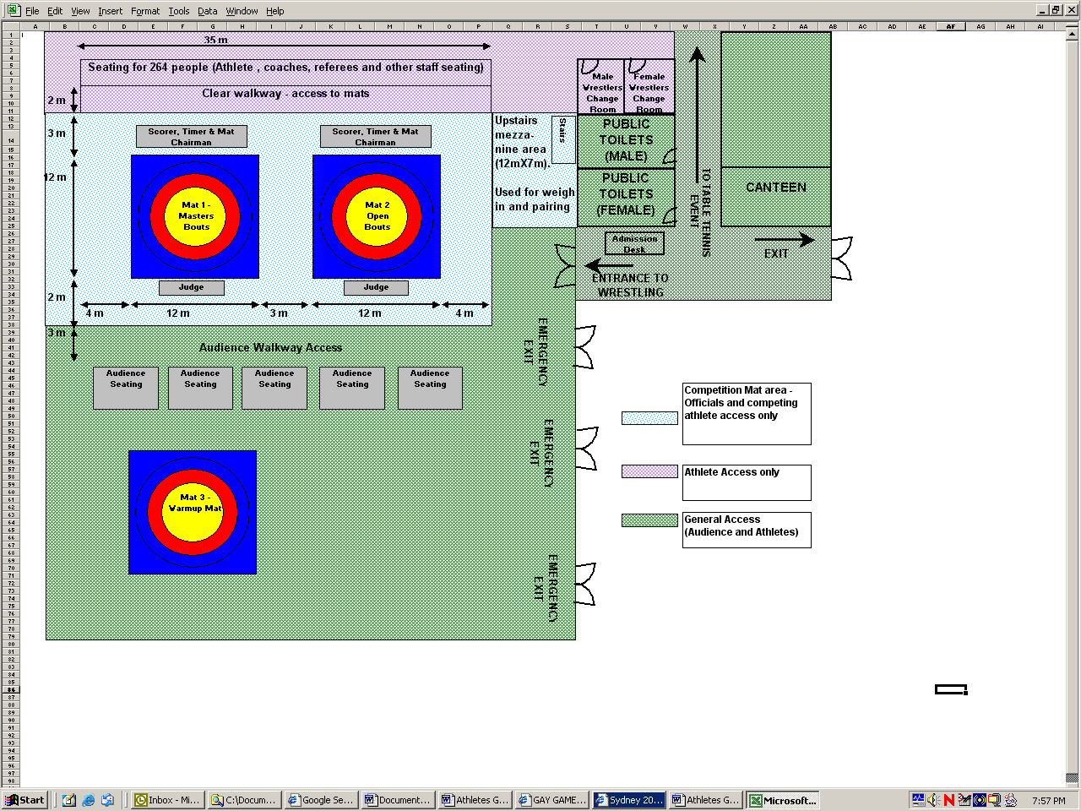

Getting to the venue
The wrestling events are to be held at the Anne Clark Netball Centre, which is located in the suburb of Lidcombe, some 15km west of the Sydney CBD. Parking is available at the centre, although athletes and viewers are encouraged to make use of public transport facilities.
To get there by public transport:
- From Central Station, take either the Inner West Line or the Bankstown Line to Lidcombe Railway Station. Trains that pass through Lidcombe run about every 10 minutes. The journey from Central station to Lidcombe is roughly 30 minutes.
- From Lidcombe station, turn left into Church St, heading away from the City.
- Anne Clark Centre is a 10-minute walk, past Auburn Swimming pool complex and Lidcombe oval. See below for maps.
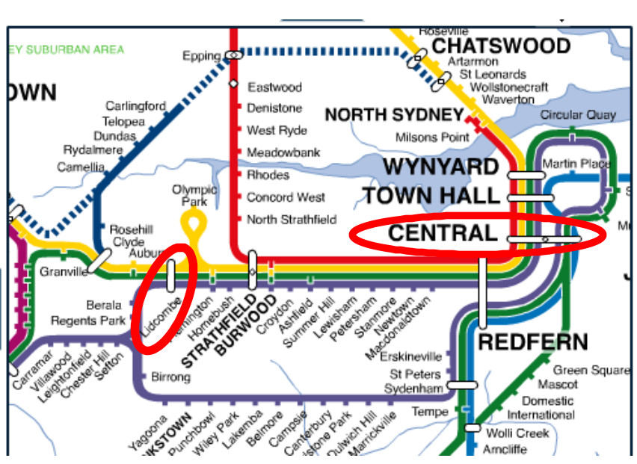
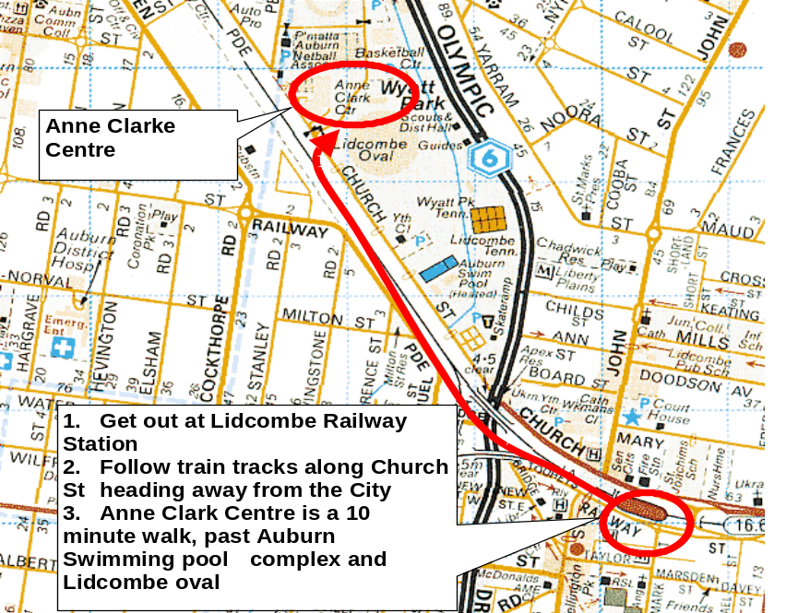

Rules

Wrestling will be governed by the rules of the FILA with some modifications. The rules for scoring will be the FILA rules current at the time of competition, as overseen by New South Wales Wrestling Association Incorporated, which is the state body of the national association.

- To be eligible to enter the Open and Masters competition wrestlers must show proof that they are a member of an organisation affiliated with FILA.
- FILA licenses are not required (although they are acceptable). What is required is a local FILA affiliate card. Any wrestler that cannot prove membership of their local FILA affiliated body will need to become members of the NSWWA before being eligible to enter the competition. The cost to become a member of the NSWWA is AU$130.
- This does not apply to the novice workshops on Sunday 3 November.
A wrestler must choose to compete in only one age division.
- Open division is for competitors of 18 years to less than 35 years
- Masters division is for competitors of 35 years and older.
- Wrestlers in the Open age group can only compete in the Open division.
- Wrestlers in the Masters age group may elect to compete in the Open OR the Masters division, subject to the agreement of the referees.

Competition is gender segregated; mixed bouts will NOT be permitted for competition.
- However, mixed training during the novice workshop will be encouraged.
- Mixed special bouts may be arranged, at the discretion of the Competition Manager and Referees.
- FILA rules recognize only the legal definition of gender as specified on a passport.

Weight categories

For both Open and the Masters competition the weight classes for both Men and Women are as follows:
50kg Weights up to 50.0kg
55kg 50.01kg to 55kg
60kg 55.01kg to 60kg
66kg 60.01kg to 66kg
74kg 66.01kg to 74kg
84kg 74.01kg to 84kg
96kg 84.01kg to 96kg
120kg 96.01kg to 120kg

- All competitors will be required to have a medical examination prior to weigh in, as per FILA regulations. The sole purpose of the medical is to check for any contagious skin conditions.

Wrestling Attire

For competition day, standard wrestling attire is to be used, that is, regulation primarily Red and primarily Blue singlets. Wrestlers are to have a personal handkerchief or towel handy to remove excess sweat from their bodies during bouts. Regulation wrestling shoes are to be worn, preferably with the shoelaces taped down. Optional headgear and kneepads may be worn. T-shirts, and/or shorts are not acceptable for competition on the Monday, however may be worn on the Novice training day.

Competition Format

- The competition will follow modified FILA rules regarding tournament format.
- For weight divisions with five or less wrestlers, the FILA Nordique Tournament System will be used where each competitor wrestles each other competitor in that weight division. In other words, if there are five participants in a particular weight division, each competitor will have four bouts to determine placings.
- For weight divisions with six to eight wrestlers, the competition will be by double elimination.
- For weight divisions with nine or more wrestlers, the division will be split into two (2) separate weight classes. Medals will be awarded to first, second and third placegetters in both classes. Each class will have its own elimination and final rounds.

Separation Criteria within weight brackets:

- Where possible, separation criteria will be used within each weight division.
- The criteria will be by Club, then City/Region and then Random Draw.
- The rationale for this rule is to ensure that wrestlers within each weight bracket have the chance to wrestle someone different from their team-mates. It also accords with the Games creed of inclusion, participation and personal best.
- This information will be collected from each competing athlete prior to or at the weigh in.

Rule where there is only One (1) wrestler in a weight class

- Where, after weigh-in, there is only one wrestler in a weight class, that wrestler may be given the choice of whether to wrestle in a heavier/younger division (subject to the discretion of the officials of the NSWWA) or opt to stay put.
- If the wrestler opts to remain where he/she is, that wrestler will be awarded a gold medal.
- Exhibition, or “special” bouts may be arranged with another wrestler of a similar weight and experience, providing both wrestlers agree and subject to the overriding discretion of the NSWWA officials.

Rule where there are only two (2) wrestlers in a weight class

- Where, after weigh-in, there are only two (2) wrestlers in a weight class, each must wrestle the other.
- First and second placegetter medals will be awarded.
- As each wrestler will only wrestle one match, and weight divisions with more entries will wrestle a minimum of two matches, exhibition/special bouts may be arranged with another wrestler of similar weight and experience, providing that both wrestlers agree, it meets with the approval of officials of the NSWWA and there is sufficient time to allow it.

Dispute resolution – procedure – appeals

The decision of the referee on the mat is final.

Cities and Countries Represented
The following Nations are represented at Sydney 2002 Gay Games VI:
United Arab Emirates, Australia, Belgium, Canada, Germany, France, Hong Kong, Ireland, Netherlands, New Zealand, United Kingdom, United States

Athletes originate from the following cities:
Abu Dhabi, Amsterdam, Antwerp, Arlington, Austin, Ballinasloe, Bay Shore, Berlin, Brisbane, Brooklyn, Chicago, Christchurch, Clarks Summit, Colorado Springs, Concord, Denver, Edinburgh, Fort Lauderdale, Frankfurt, Harrisburg, Heilbronn, Honolulu, Jackson Heights, Kapa'a, Koenigheim, Lake View Terrace, Linden, Long Beach, Los Angeles, Melbourne, Milton, Montreal, New York, North Point, Paris, Philadelphia, Portland, Pulle, Reading, Rieschweiler, Rolleston, San Diego, San Francisco, Santa Rosa, Seattle, Smyrna, St. Petersburg, Stuttgart, Sydney, Tampa, Tucson, Vallejo, Vancouver, Verdun, West End, Wilrijk, Winnetka and Würzburg

Medal ceremonies information

- All registered wrestlers will receive a participation medal.
- To recognise personal achievement in Wrestling, medals will be awarded for first, second and third place in each of the divisions and weight categories in the Open and Masters competition. This will apply for both men’s and women’s classes.
- Where weight divisions have been split into two separate classes, gold silver and bronze medals will be awarded to the first, second and third placegetters in each class.
- Medals will be presented at the conclusion of the tournament.

Results information

- Results data will be collected during the day, and will be posted on the Sydney 2002 Gay Games website following the completion of the competition.
- A full list of participants’ names, their city location and placing within weight division and category will be posted, subject to participants’ agreement to such details being disclosed.
- Where participants have requested anonymity, such information will be withheld.

Ticketing information

You can catch all the Wrestling action for one day of competition only on Monday 4 November when European, American, Canadian and Aussie wrestlers battle it out on the mat. Limited spaces are still available, however, ticketing will be closed at 400 spectators.

- Tickets cost $15.00 (plus $1.50 Booking fee), and must be purchased via the Ticketek website, http://premier.ticketek.com.au/Ticketek/default.asp
- Overseas guests are strongly advised to select venue collection as the delivery option to ensure the safety of your tickets purchased.
- All Wrestling events are free for registered Sydney 2002 Wrestling participants and their accredited coaches. Accreditation passes must be shown at the door for entry.

Medical information

- There will be a medical doctor on site during the weigh in, and for the duration of the competition day.
- In accordance with FILA regulations, bouts will be interrupted immediately should one of the competitors bleed; any spilt blood will be immediately cleaned up and the mat area disinfected. In this situation, the decision of the referee and mat-side doctor is final.
- NSWWA and the Sydney2002 Gay Games will be adhering to risk minimisation procedures as per FILA regulations.
- Sydney is well equipped with modern public hospital infrastructure. In the event of an emergency, medical aid can be obtained by telephoning 000 and requesting ambulance services.

Sports specific social functions

Harbour City Wrestling Club is pleased to be hosting the unofficial Welcome to Sydney social functions for wrestlers. More information about our club (as well as any updates for the social functions) can be found on http://www.froggy.com.au/jarek/hcwc/index.html

The social events have been scheduled for Wednesday afternoon and Thursday evening, so that competing athletes don’t have to worry about alcohol intake or weight restrictions, and so that conflicts with other social and sporting events are minimised. This is a chance for Gay Games wrestlers to train informally, have the opportunity to purchase and/or exchange club memorabilia, and enjoy some drinks and snacks in a friendly atmosphere.

Event 1: Harbour City Wrestling Club Training and Social Meet

Where: Boxing Works, 167 Castlereagh St, Sydney (upstairs)
The venue is an easy 2-minute walk from the Queen Victoria Building or Town Hall train station, has bus stops in every direction and is located on Castlereagh St between Park and Market Sts.

When: Wednesday 6th November from 14:30h – 18:00h

Cost: $5 for Gay Games registered athletes, $10 to general public/spectators, free to wrestling accredited volunteers
Timetable:
- 14:30-16:15 The wrestling mat will be available for wrestlers to do some light training/ informal bouts
- 16:15-16:30 Shower and freshen up
- 16:30-17:45 Enjoy some drinks and light refreshments and browse souvenirs and memorabilia from the various wrestling clubs represented at Sydney2002 Gay Games.
- 17:45 Conclusion and clean up (we have a time limitation on the venue)
- 18:00 onwards After the social event we intend to have dinner at a local restaurant to continue informal nature of the evening. Details will be advised at the conclusion of the training event. Dinner cost is pay your own way.

Contact Details: Kurt Phone: XXX XXX XXX

Wrestling Clubs represented at the Sydney 2002 Gay Games are encouraged to bring their own club memorabilia for sale at this event. It is suggested that they set up their wares some time prior to the social drinks commencing at 16:30h. Contact Kurt for more details if required.

Event 2: Wrestlers meet the Bears at The Beresford
On the evening of Thursday 7th we plan to have informal social drinks at “The Beresford” around 2100h for a chance to “meet the local wildlife”. The Beresford is one of the most popular watering holes in the Oxford St area (Sydney’s best known gay precinct) and is particularly well frequented by Sydney’s bear community. The Beresford is a short (10 min) taxi ride from the Hordern pavilion for those partygoers attending the “Black” men’s party later in the evening.

Cost: Pay your own way
Contact Details: Basil Phone: XXX XXX XXX

Appendix (7) Wrestler Bio Sheet

The following information was provided by athletes to aid the announcer and medal presenter:

Wrestler Bio Information Sheet

Personal Bio Information:
The following information is OPTIONAL and is used for the purposes of providing background information about medal winners and the Sydney2002 Gay Games Commemorative book. Please use Block Letters to Aid Legibility

Athlete Name:
Phonetic Pronunciation:
Nationality:
Home City:
Current Training Team (if applicable):
Number of Years Experience in Wrestling:
Level of Experience: (Beginner/Intermediate/Experienced/Coach)
Competition Level (Masters/Open Mens/Womens)
Weight Category
Teams you Have Wrestled With:
Previous Gay Games Attended:
Other Competition Experience (include details of medals won):

Appendix (8) Wrestler Weigh In Sheet

The following information was provided by athletes for the weigh in medical check process

Wrestler Weight, Category & Home City Information
The following information is required for the purposes of pairing bouts and MUST be completed.
PLEASE USE BLOCK LETTERS TO AID LEGIBILITY
Name:
Gender (Male/Female):
Current Training Team/Affiliation (if applicable):
Home City:
Nationality:
Prior Competition Experience? (Yes/No):
Years Experience in Wrestling:
Any Special Needs or Disabilities? (Yes/no):
Provide Details & requirements

Office Use Only
1. AFFILIATION CHECK
Licence type (eg FILA, NSWWA, USAW)
License Number
2. AGE CHECK
Birthdate as listed on license/passport
Age as of Nov 4 2002
Name of checker
Signature
3. MEDICAL CHECK (Tick appropriate box):
This participant (IS /IS NOT) free of contagious skin disease.
Name of authorising physician
Signature
4. WEIGH IN
Actual Weight Recorded:
Date:
Recorded By:
Signature:
Competition Category (Tick only one) :
MASTERS MEN MASTERS WOMEN OPEN MEN OPEN WOMENS
Weight Class (Tick only one) :
50 kg 55 kg 60 kg 66 kg 74 kg 84 kg 96 kg 120 kg

Wrestler Draw Number = (Input the number randomly drawn by wrestler).

